Don’t Stop the Music: Spotify Churn Prediction
Harrisburg University of Science and Technology
ANLY 500-50- A- Analytics I: Prin & Applications
Matt Hubley
February 20, 2026

Group 4:
Ting Ding
Maitri Dhiren Gosrani
Kishankumar Pandor
Wahida Islam Talukder

Don't Stop the Music: Spotify Churn Prediction

1. Introduction

Spotify operates its business through a premium business model which allows users to listen to music without payment while experiencing advertisements or choose to pay for Premium service which provides them with an advertisement-free listening experience. The company depends on Premium subscribers to sustain its recurring revenue stream which requires them to keep their subscribers engaged. Spotify currently competes with major streaming services such as Apple Music, YouTube Music, and Amazon Music in a highly competitive music streaming industry. In this type of tough market competition, businesses must focus on keeping customers because even a small increase in premium customer churn creates substantial revenue decline. Accurate prediction of customer departure provides Spotify with essential strategic and financial benefits which support its capacity to achieve sustainable growth. Previous research demonstrates that even minor reductions in customer churn will lead to substantial increases in subscription-based business profitability (Jolaoso & Badmus 2020).

2. Motivation

Data analytics serves as an effective method for resolving subscription churn issues because it provides us with the ability to analyze user demographics and listening patterns together with engagement data to discover actual warning indicators. The development of a predictive churn model enables organizations to implement data-driven retention strategies which establish customer loyalty through their ongoing relationship with users. Currently, businesses lack effective methods to handle customer retention processes. Companies face difficulties in transforming complex behavioral and demographic models into straightforward marketing tools that can help them reduce customer churn despite studies showing their predictive accuracy for churn forecasting (Umezurike et al., 2025). Traditional methods that do not use analytical techniques fail to meet current requirements because they cannot accurately identify user behaviors that lead to cancellations. We require that level of detail because it enables us to develop retention campaigns which provide personalized and effective results.

3. Problem Definition

The main goal of this project is to build and evaluate a supervised machine learning model that can figure out which Spotify Premium users are most likely to cancel their subscriptions, all based on their everyday listening habits. This challenge requires us to blend business strategy with analytics: we want to take raw behavioral data and turn it into clear business insights by sorting users into "at-risk" or "retained" buckets using classification algorithms.

To tackle this, our project will dig into the following core research questions:

1. Among Spotify-like premium customers, which behavioral and engagement characteristics most accurately predict churn?

2. How well can users be classified into "at-risk" and "retained" categories using common classification algorithms?

3. How accurately can a Spotify Premium churn prediction algorithm forecast each user's likelihood of canceling within a specified time frame?
- Spotify business model
- Market competition
- Why churn matters financially
- Revenue implications
4. Related Work
- Prior Churn Prediction Research: Customer churn prediction has been widely studied in subscription-based industries. Prior research shows that user churn does not occur randomly but is often preceded by observable behavioral changes. Verbeke et al (Verbeke, 2012) demonstrated that churn can be effectively predicted using historical customer behavior data in the telecommunications sector, highlighting the value of predictive modeling for early identification of at-risk users. These findings suggest that behavioral indicators can serve as reliable signals of future churn, providing a strong foundation for churn prediction in digital subscription platforms such as music streaming services.
- Machine Learning in Subscription Platforms: Machine learning techniques have been increasingly applied to improve customer retention in subscription-based business models. Verbeke et al (Verbeke, 2012) compared multiple predictive models and found that data-driven approaches significantly outperform traditional rule-based methods in identifying churn risk. Although much of this research focuses on industries such as telecommunications and finance, the underlying principles are transferable to digital platforms like Spotify, where user engagement and subscription renewal decisions follow similar patterns.
- RFM Framework and Behavioral Features: User behavior frameworks such as the RFM (Recency, Frequency, Monetary) model provide a structured way to summarize engagement patterns. While not explicitly framed as RFM, research on music recommendation systems emphasizes the importance of user interaction frequency, listening behavior, and engagement over time. Bonnin and Jannach (Bonnin, 2024) showed that behavioral usage data plays a critical role in understanding user preferences and continued platform usage. These findings support the use of RFM-like behavioral features when modeling churn in music streaming platforms.
- Time-Based Churn Modeling: Churn is inherently a time-dependent process, as users typically disengage gradually rather than canceling abruptly. Verbeke et al (Verbeke, 2012) emphasized that temporal changes in customer behavior often precede churn events, making time-based modeling especially valuable. This perspective aligns with streaming platform usage; declining activity, reduced listening frequency, or shortened session duration may signal an increased likelihood of cancellation. Incorporating time-based behavioral trends therefore enhances both predictive accuracy and interpretability.
5. Industry Context
Spotify operates under a freemium business model, offering users a choice between an ad-supported free tier and a paid Premium subscription that removes advertisements and provides additional features. Because Premium subscriptions are Spotify’s primary source of recurring revenue, retaining paying users is essential to the company’s long-term financial performance (S.A., 2023).
Spotify operates in a highly competitive streaming market, facing direct competition from platforms such as Apple Music, YouTube Music, and Amazon Music. These services offer similar pricing, large music catalogs, and personalized recommendation features, which lowers switching costs and increases the risk of customer churning.
To improve retention, streaming platforms emphasize personalization and user engagement strategies. Features such as personalized playlists, recommendation algorithms, and tailored listening experiences are designed to increase user satisfaction and time spent on the platform (Bonnin, 2024). However, personalization alone may not be sufficient to prevent churn without understanding early signals of user disengagement.
As a result, many companies have adopted predictive analytics techniques to better understand and anticipate customer churn. By analyzing user behavior and engagement patterns, predictive models can identify users at risk of leaving before churn occurs. Prior research shows that predictive churn models can significantly enhance retention strategies and improve business outcomes in subscription-based industries (Verbeke, 2012).

6. Data

6.1 Data Source
The dataset used for this analysis is the Sparkify Mini dataset, a publicly available dataset that simulates user interaction logs for a music streaming platform like Spotify. The dataset contains approximately 286,500 event-level records representing user interactions such as song plays, login events, subscription changes, and cancellation confirmations.
The dataset was selected because it provides granular behavioral logs suitable for modeling churn behavior in a subscription-based streaming environment.

6.2 Data Structure
The dataset is structured at the event level, meaning each row represents a single user interaction. Key fields include:
- userId – Unique identifier for each user
- page – Type of user event (e.g., NextSong, Login, Cancellation Confirmation)
- ts – Timestamp of event in milliseconds
- sessionId – Session identifier
- level – Subscription tier (free or paid)
After preprocessing and removal of empty user identifiers, the dataset contained 225 unique users.

6.3 Target Variable Construction
The dependent variable in this study is churn.
Churn was defined as a binary indicator:
- 1 = User reached a “Cancellation Confirmation” event
- 0 = User did not reach a cancellation event
Users were labeled as churned if at least one cancellation confirmation event was observed in their event history. The final churn rate in the dataset was approximately 23%, indicating moderate class imbalance.

6.4 Data Cleaning and Preprocessing
Several preprocessing steps were conducted:
- Removal of records with empty user identifiers
- Conversion of timestamp values from milliseconds to POSIX date-time format
- Aggregation of event-level logs to user-level features
- Verification of missing values (no missing values remained after aggregation)
No imputation was required as the final user-level dataset contained complete feature values.

6.5 Exploratory Data Analysis
Prior to model development, exploratory analysis was conducted to understand churn distribution and preliminary behavioral patterns.
At the user level, approximately 23% of users were labeled as churned, indicating moderate class imbalance. Figure 1 presents churn rates segmented by subscription level.
Figure 1. Churn rate by subscription level
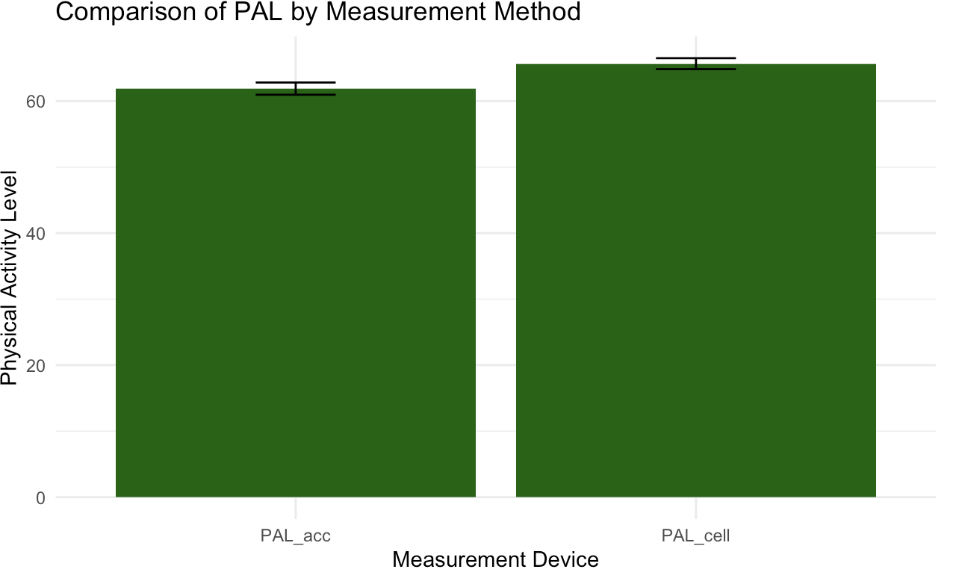
As shown in Figure 1, free-tier users exhibit a slightly higher churn rate compared to paid users. Although the difference is modest, this finding suggests that subscription level may contribute to retention dynamics and warrants of inclusion as a predictive feature.

6.6 Feature Engineering
Event-level logs were transformed into user-level behavioral features to support predictive modeling. The following features were constructed:
- Total Songs Played – Number of “NextSong” events per user
- Total Sessions – Number of distinct session identifiers per user
- Average Session Length – Mean duration of user sessions in minutes
- Subscription Level – Final known subscription tier (free or paid)
- Days Since Last Activity (Recency Feature) – Number of days between the user’s most recent event and the maximum observed timestamp in the dataset
The inclusion of the recency feature (days_inactive) captures temporal disengagement patterns, which are commonly associated with churn behavior in subscription services. Figure 2 further examines inactivity patterns by churn status.
Figure 2. Distribution of days inactive by churn status.
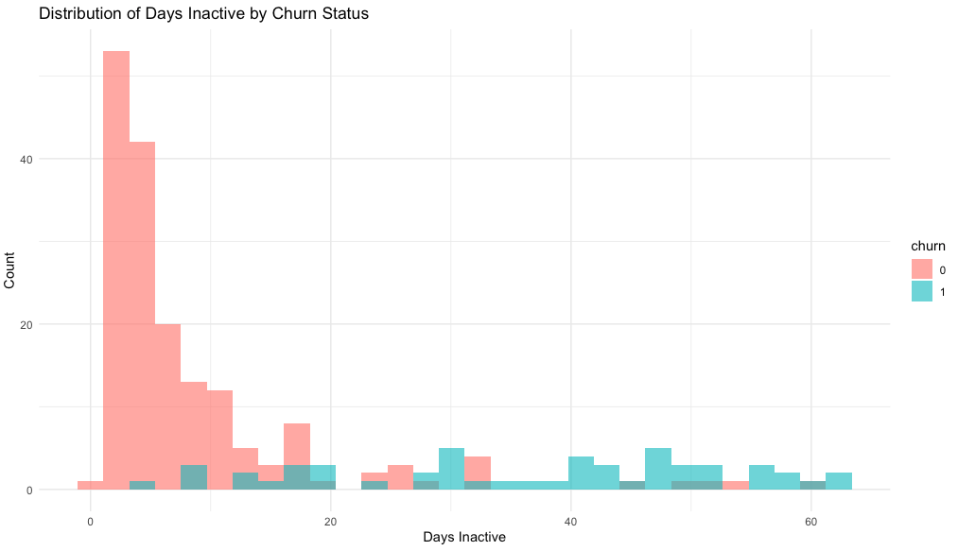
Figure 2 demonstrates a clear separation between churned and retained users in terms of inactivity duration. Churned users exhibit substantially longer periods of inactivity prior to cancellation, motivating the inclusion of recency-based features in subsequent modeling

6.7 Final Modeling Dataset
The final modeling dataset consisted of:
- 225 users
- 1 binary target variable (churn)
- 5 independent variables (level, total_songs, total_sessions, avg_session_length, days_inactive)
An 80/20 train-test split was applied to evaluate model performance.

7. Technical Approach

7.1 Overview of Analytical Workflow
This project followed a structured analytics workflow aligned with the CRISP-DM framework, consisting of data understanding, data preparation, modeling, evaluation, and interpretation. The objective was to develop a predictive model capable of identifying users at risk of churn based on behavioral engagement patterns.
The workflow included:
- Event-level data preprocessing
- User-level feature aggregation
- Baseline model development
- Model enhancement through feature expansion
- Comparative evaluation of classification models

7.2 Data Aggregation Strategy
The original dataset was structured at the event level, meaning each record represented a single user interaction. However, churn prediction requires modeling at the user level.
To address this, event-level logs were aggregated into user-level behavioral features. The aggregation process included:
- Counting total song plays per user
- Calculating total distinct listening sessions
- Computing average session duration in minutes
- Extracting the most recent subscription level
- Calculating recency via days since last activity
The inclusion of recency (days_inactive) was motivated by established churn modeling frameworks such as RFM (Recency, Frequency, Monetary), where recency is often the strongest predictor of disengagement.

7.3 Feature Selection Rationale
The selected features represent multiple dimensions of user behavior:
- Engagement Intensity: total songs played
- Usage Frequency: total sessions
- Engagement Depth: average session length
- Subscription Context: free vs paid
- Temporal Disengagement: days since last activity
The goal was to capture both static engagement metrics and temporal patterns associated with churn risk.

7.4 Model Development

7.4.1 Baseline Model – Logistic Regression
Logistic regression was selected as the baseline model due to:
- Interpretability of coefficients
- Suitability for binary classification
- Ability to quantify the direction and magnitude of predictor effects
An 80/20 train-test split was applied using a fixed random seed to ensure reproducibility.
The baseline model included:
churn ~ level + total_songs + total_sessions + avg_session_length
Initial performance yielded moderate discrimination, establishing feasibility of churn prediction.

7.4.2 Enhanced Model – Logistic Regression with Recency
Following baseline evaluation, a recency-based feature (days_inactive) was introduced to capture temporal disengagement behavior. The updated model specification included this feature alongside engagement metrics.
Model estimation results indicated that days_inactive was highly statistically significant (p < 0.001) and exhibited a positive association with churn probability.
Figure 3. Odds ratios from enhanced logistic regression model. 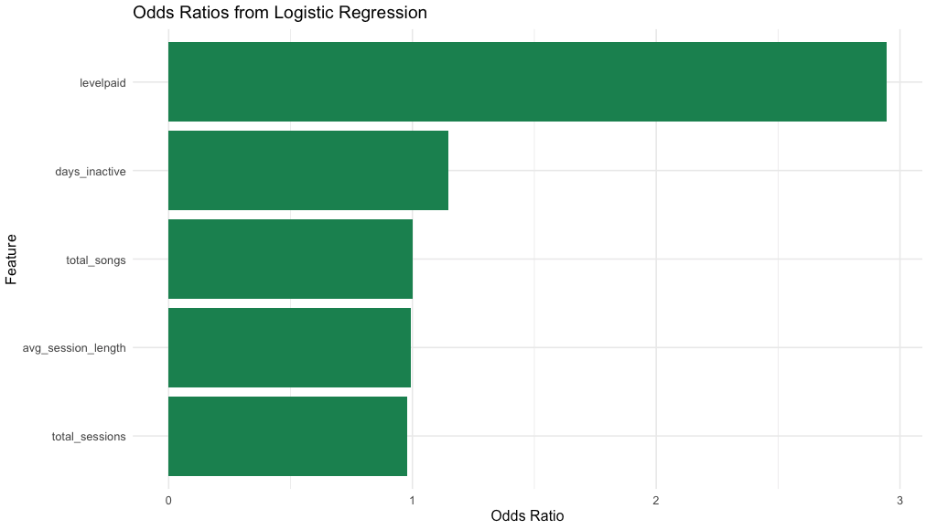
Values greater than 1 indicate increased odds of churn. Days_inactive demonstrates a consistent positive association with churn probability. Although subscription level exhibits a larger odds ratio, it is not statistically significant (p = 0.134). In contrast, days_inactive is highly significant (p < 0.001) and consistently emerges as the dominant churn predictor across modeling approaches.

7.4.3 Comparative Model – Random Forest
To assess whether non-linear relationships improved predictive performance, a Random Forest classifier was trained using the same feature set.
Random Forest was selected because:
- It captures non-linear interactions
- It is robust to multicollinearity
- It provides feature importance metrics
Five hundred trees were grown (ntree = 500), and variable importance was assessed using mean decrease accuracy and mean decrease Gini.

7.5 Model Validation Strategy
Model performance was evaluated using:
- Accuracy
- Receiver Operating Characteristic (ROC) Curve
- Area Under the Curve (AUC)
ROC-AUC was emphasized as the primary evaluation metric due to class imbalance and its ability to measure discrimination independent of classification thresholds.
All models were evaluated on the held-out test set to prevent overfitting.

7.6 Implementation Environment
The analysis was conducted using R. Key libraries included:
- dplyr (data manipulation)
- ggplot2 (visualization)
- pROC (ROC analysis)
- randomForest (ensemble modeling)
A fixed random seed was used to ensure reproducibility of train-test splits and model evaluation.

8. Testing and Evaluation

8.1 Evaluation Strategy
Model performance was evaluated using a held-out test set comprising 20% of the dataset (45 users), while 80% (180 users) was used for training. A fixed random seed was applied to ensure reproducibility of the train-test split.
Given the presence of moderate class imbalance (approximately 23% churn rate), evaluation focused primarily on Receiver Operating Characteristic (ROC) curves and Area Under the Curve (AUC) rather than accuracy alone. ROC-AUC is threshold-independent and provides a robust measure of a model’s ability to discriminate between churned and retained users.
Accuracy was also reported but interpreted cautiously due to potential imbalance effects.

8.2 Baseline Model Performance
The baseline logistic regression model included the following predictors:
- Subscription level
- Total songs played
- Total sessions
- Average session length
This model achieved:
- Accuracy: 66.7%
- ROC-AUC: 0.664
The baseline results indicated moderate discriminatory power, suggesting that engagement-based features contain predictive signals. However, performance was limited, motivating further feature enhancement.

8.3 Enhanced Logistic Regression Model
To improve predictive performance, a recency-based feature (days_inactive) was incorporated into the model.
The enhanced logistic regression model achieved:
- ROC-AUC: 0.944
This represents a substantial improvement in discriminatory power compared to the baseline model.
Figure 4 illustrates the ROC curve comparison between the baseline model, enhanced logistic regression, and the Random Forest classifier.
Figure 4. ROC curve comparison across baseline logistic regression, enhanced logistic regression, and Random Forest models.
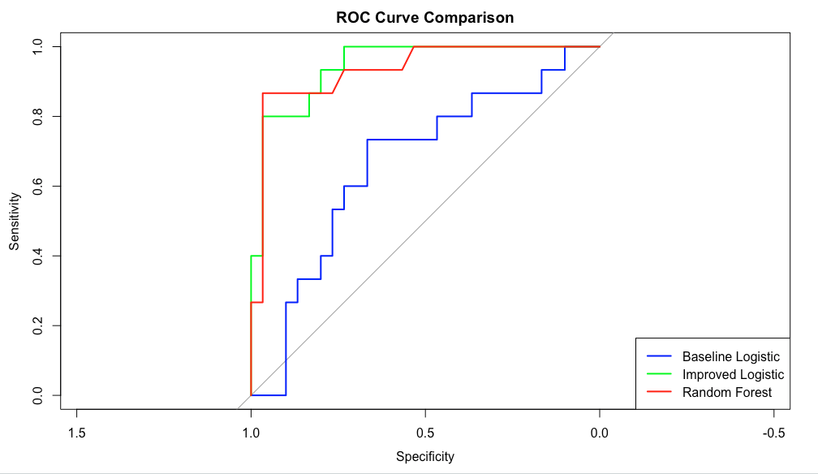
As shown in Figure 4, the inclusion of recency significantly improved model performance. The enhanced logistic regression curve demonstrates near-perfect separation between churned and retained users relative to the baseline model.

8.4 Random Forest Model Comparison
To assess whether non-linear relationships further improved performance, a Random Forest classifier was trained using the same feature set as the enhanced logistic regression model.
The Random Forest model achieved:
- ROC-AUC: 0.933
Although performance was strong, it did not exceed the enhanced logistic regression model. This suggests that the relationship between recency and churn is sufficiently strong and approximately monotonic, allowing a linear model to perform competitively.

8.5 Feature Importance Analysis
To validate the relative contribution of predictors, feature importance was assessed using the Random Forest model.
Figure 5. Random Forest feature importance based on mean decrease in accuracy and Gini index.
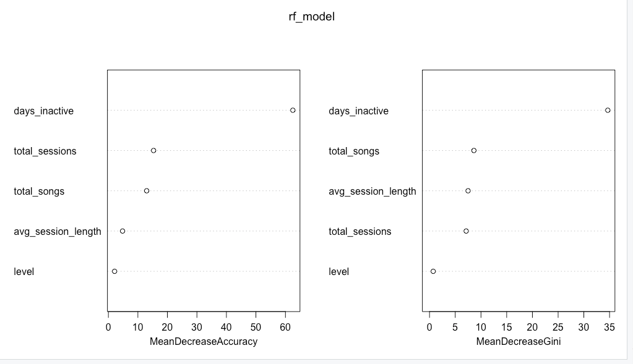
Figure 5 confirms that days_inactive is the dominant predictor across modeling approaches. All other features contributed comparatively less to predictive performance.
These findings are consistent with the logistic regression coefficient analysis presented earlier, reinforcing the robustness of recency as a churn driver.

8.6 Statistical Interpretation
In the enhanced logistic regression model, the coefficient for days_inactive was highly statistically significant (p < 0.001). The estimated coefficient of 0.138 corresponds to an odds ratio of approximately 1.15.
This implies that each additional day of inactivity increases the odds of churn by approximately 15%, holding other variables constant.
This result aligns with established churn modeling literature, where recency is frequently identified as a primary driver of disengagement.

8.7 Model Validity and Limitations
While the enhanced model demonstrates strong predictive performance, several considerations are necessary:
- The dataset is limited to 225 users, which may restrict generalizability.
- The dataset is synthetic and may not capture full real-world behavioral complexity.
- The recency feature is computed relative to the maximum observed timestamp, which may not perfectly reflect operational deployment conditions.
Despite these limitations, model evaluation was conducted on a held-out test set to reduce overfitting risk, and consistent findings across logistic regression and Random Forest models strengthen confidence in the results.

8.8 Classification Performance at Threshold 0.5
Figure 6. Confusion matrix heatmap for enhanced logistic regression model at threshold 0.5.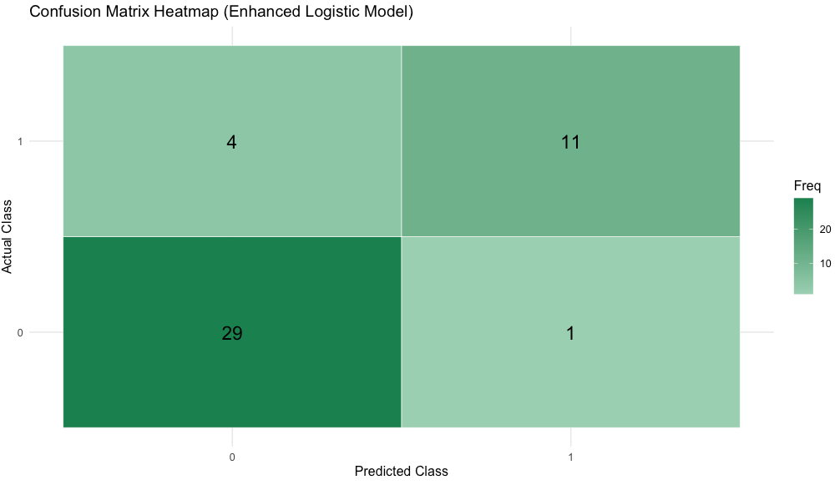
At a probability threshold of 0.5, the enhanced logistic regression model achieved an overall accuracy of 88.9% on the test set.
The model correctly classified 29 retained users and 11 churned users, with only 5 total misclassifications.
Sensitivity (recall for churned users) exceeded 70%, while specificity for retained users exceeded 95%. Balanced accuracy was 85%, indicating strong performance across both classes despite moderate class imbalance.
These results confirm that the enhanced model not only demonstrates strong discrimination via ROC-AUC but also performs well under a practical classification threshold.

9. Results

9.1 Summary of Model Performance
The objective of this study was to evaluate whether user engagement behavior can effectively predict subscription churn.
The baseline logistic regression model achieved an ROC-AUC of 0.664, indicating moderate discriminatory power based solely on engagement intensity and usage features.
After incorporating a recency-based feature (days_inactive), the enhanced logistic regression model achieved an ROC-AUC of 0.944, representing a substantial improvement in predictive performance.
The Random Forest classifier achieved an ROC-AUC of 0.933, performing slightly below the enhanced logistic regression model but confirming consistent predictive structure across modeling approaches.
These findings demonstrate that temporal disengagement patterns significantly enhance churn prediction accuracy.

9.2 Interpretation of Key Predictors
The most influential predictor across both models was days_inactive.
The logistic regression coefficient for days_inactive was highly statistically significant (p < 0.001), with an estimated odds ratio of approximately 1.15. This indicates that each additional day of inactivity increases the odds of churn by approximately 15%, holding other variables constant.
In contrast, engagement-based metrics such as total songs played and total sessions were not statistically significant in the enhanced model. This suggests that while overall engagement level contributes to some predictive signal, recency of engagement is a substantially stronger determinant of churn behavior.
Random Forest feature importance analysis further validated this finding, as days_inactive demonstrated the largest contribution to predictive accuracy.

9.3 Classification Performance
At a probability threshold of 0.5, the enhanced logistic regression model achieved:
- Accuracy: 88.9%
- Balanced Accuracy: 85%
- Strong recall for churned users
- High specificity for retained users
The confusion matrix (Figure 6) indicates that only five users were misclassified in the test set, reflecting strong classification performance in addition to high discrimination measured by ROC-AUC.
Together, these results suggest that the enhanced model performs robustly under both threshold-independent and threshold-based evaluation of metrics.

10. Business Implications
10.1 Operational Meaning of Model Results
The enhanced logistic regression model achieved an ROC-AUC of 0.944, indicating strong discriminatory power in identifying users at risk of churn. From a business analytics perspective, this level of performance suggests that behavioral recency is a highly informative signal for subscription disengagement. Prior research in customer analytics consistently identifies recency as one of the strongest predictors of churn behavior (Fader et al., 2005; Lemmens & Croux, 2006).
The odds ratio of approximately 1.15 for days_inactive implies that each additional day of inactivity increases the odds of churn by 15%, holding other factors constant. This aligns with the Recency–Frequency–Monetary (RFM) framework, which emphasizes recency as a dominant behavioral indicator of customer attrition risk (Fader et al., 2005).
Operationally, this means that Spotify does not necessarily require highly complex behavioral tracking systems to generate retention value. A structured inactivity-based monitoring system could provide significant predictive leverage.
10.2 Designing Inactivity Thresholds
Based on the modeling results, Spotify could operationalize churn risk segmentation using inactivity thresholds:
- Low Risk: 0–3 days inactive
- Moderate Risk: 4–7 days inactive
- High Risk: 8+ days inactive
Threshold-based intervention strategies are consistent with applied churn management literature in subscription industries (Lemmens & Croux, 2006).
Once a user enters a high-risk tier, automated retention mechanisms may include:
- Personalized push notifications
- Discounted premium offers
- Algorithmically curated playlists
- Re-engagement email campaigns
Proactive intervention aligns with predictive customer retention strategies commonly used in digital subscription platforms (Ngai et al., 2009).
10.3 Early Warning System Architecture
The predictive model supports development of an Early Warning Retention System (EWRS) structured as follows:
- Daily inactivity scoring
- Risk probability estimation via logistic regression
- Risk tier segmentation
- Automated marketing activation
- Continuous feedback and retraining
This workflow aligns with structured analytics methodologies such as CRISP-DM, which emphasizes iterative deployment and evaluation cycles (Chapman et al., 2000).
10.4 Financial Impact and Business Value
Customer churn directly impacts Customer Lifetime Value (CLV), revenue predictability, and acquisition cost efficiency. Research shows that even small reductions in churn can substantially improve long-term profitability in subscription-based business models (Gupta et al., 2006).
By identifying churn risk early, Spotify could:
- Increase retention rates
- Improve CLV projections
- Reduce marketing acquisition dependency
- Stabilize recurring revenue streams
Given the model’s reliance on simple behavioral metrics, implementation costs are relatively low compared to potential revenue preservation, making the return on analytics investment highly favorable.

11. Limitations
11.1 Small Sample Size
The dataset contains only 225 users. While performance metrics are strong, small sample sizes increase the risk of statistical variance and limit external validity.
Larger datasets would improve generalizability and allow for more robust validation procedures.
11.2 Synthetic Dataset Constraints
The Sparkify dataset is synthetic and may not reflect the full behavioral complexity of real-world streaming platform users. Real production environments typically incorporate additional signals such as payment behavior, device type, location, and marketing exposure. Thus, model deployment would require retraining using authentic operational data.
11.3 Potential Overfitting
The high ROC-AUC (0.944) raises potential overfitting concerns, particularly given the small dataset size. Although a held-out test set was used, more robust validation approaches such as k-fold cross-validation or temporal validation would improve confidence in generalizability (Kuhn & Johnson, 2013).
11.4 Temporal Validation Requirement
Churn is inherently time-dependent. The current recency variable is calculated relative to the dataset’s maximum timestamp. Real-world deployment requires rolling time-window validation and out-of-time testing to ensure predictive stability (Lemmens & Croux, 2006).

12. Future Work
12.1 Time-Window Modeling
Future analysis should implement rolling-window feature engineering to simulate real-time prediction environments. This improves causal integrity and deployment realism.
12.2 Survival Analysis
Churn is a time-to-event process. Survival modeling techniques such as Cox proportional hazards regression allow estimation of hazard rates and expected time-to-churn (Cox, 1972). Survival analysis would provide richer insight into when churn occurs rather than simply whether it occurs.
12.3 Cost-Sensitive Classification
Not all churn events carry equal financial consequences. Premium subscribers typically generate higher revenue than free-tier users. Cost-sensitive classification methods incorporate financial weighting into model optimization, allowing retention strategies to maximize profit rather than accuracy alone (Elkan, 2001).
12.4 Deployment and MLOps Considerations
Future deployment would require:
- Real-time scoring pipelines
- Model monitoring for drift
- Periodic retraining
- A/B testing of retention strategies
Sustainable predictive systems require integration of analytics within business operations through structured lifecycle management (Chapman et al., 2000).

Reference
Chapman, P., Clinton, J., Kerber, R., Khabaza, T., Reinartz, T., Shearer, C., & Wirth, R. (2000). CRISP-DM 1.0: Step-by-step data mining guide. SPSS. https://www.the-modeling-agency.com/crisp-dm.pdf
Cox, D. R. (1972). Regression models and life-tables. Journal of the Royal Statistical Society: Series B, 34(2), 187–220. https://doi.org/10.1111/j.2517-6161.1972.tb00899.x
Elkan, C. (2001). The foundations of cost-sensitive learning. Proceedings of the 17th International Joint Conference on Artificial Intelligence, 973–978. https://doi.org/10.5555/1642293.1642414
Fader, P. S., Hardie, B. G. S., & Lee, K. L. (2005). RFM and CLV: Using iso-value curves for customer base analysis. Journal of Marketing Research, 42(4), 415–430. https://doi.org/10.1509/jmkr.2005.42.4.415
Gupta, S., Lehmann, D. R., & Stuart, J. A. (2006). Valuing customers. Journal of Marketing Research, 43(1), 7–18. https://doi.org/10.1509/jmkr.43.1.7
Jolaoso, V., & Badmus, O. (2020). Customer Lifetime Value (CLV) Modeling in B2B Sales: A Project Report on Long-Term Marketing and Sales Strategy Development.
Kuhn, M., & Johnson, K. (2013). Applied predictive modeling. Springer. https://doi.org/10.1007/978-1-4614-6849-3
Lemmens, A., & Croux, C. (2006). Bagging and boosting classification trees to predict churn. Journal of Marketing Research, 43(2), 276–286. https://doi.org/10.1509/jmkr.43.2.276
Ngai, E. W. T., Xiu, L., & Chau, D. C. K. (2009). Application of data mining techniques in customer relationship management: A literature review and classification. Expert Systems with Applications, 36(2), 2592–2602. https://doi.org/10.1016/j.eswa.2008.02.021
Umezurike, S. A., Akinrinoye, O. V., Kufile, O. T., Onifade, A. Y., Otokiti, B. O., & Ejike, O. G. (2025). Predictive analytics for customer lifetime value in subscription-based digital service platforms.
Bonnin, G. &. (2024). Automated generation of music playlists: Survey and experiments. ACM Computing Surveys, 47(2), 1–35. Retrieved from https://dl.acm.org/doi/epdf/10.1145/2652481
S.A., S. T. (2023). Form 20-F Annual Report. Retrieved from https://investors.spotify.com/financials/default.aspx
Verbeke, W. D. (2012). New insights into churn prediction in the telecommunication sector. Retrieved from https://www.sciencedirect.com/science/article/abs/pii/S0377221711008599?via%3Dihub

